**Pixel Team**

**Team Leader:**

* **Jamshid Ganiev / 12200335**

**Team members:**

1. **Asadbek Khoshimov / 12200306**
2. **Shokhzod Khaydarov / 12200295**
3. **Anvarbek Sabirov / 12194894**

**Steps:**

**Data collecting:**

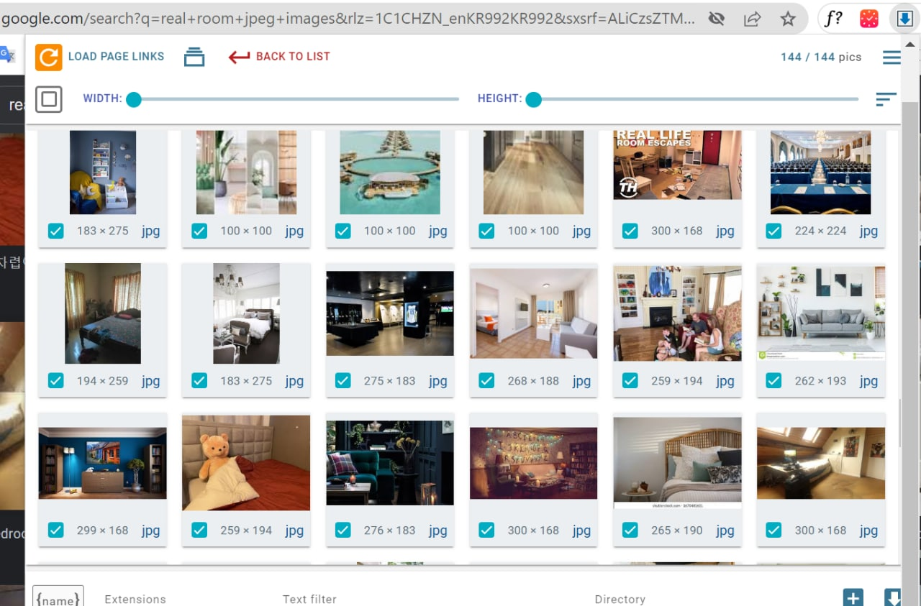

**\*We also got several datasets from kaggle.com for both negative and positive samples\***

* **As you can see, exactly 2500 positive images (images including only human faces) have been collected while the negative ones (any image excluding human faces) are four times more than the positive ones.**
* **Pay attention to file names in this step. All file names are different from each other and look extremely messy. (Next, All files are renamed by using python to avoid unexpected errors while training the model).**

**Data Cleaning:**

* **Renaming all files using python:**

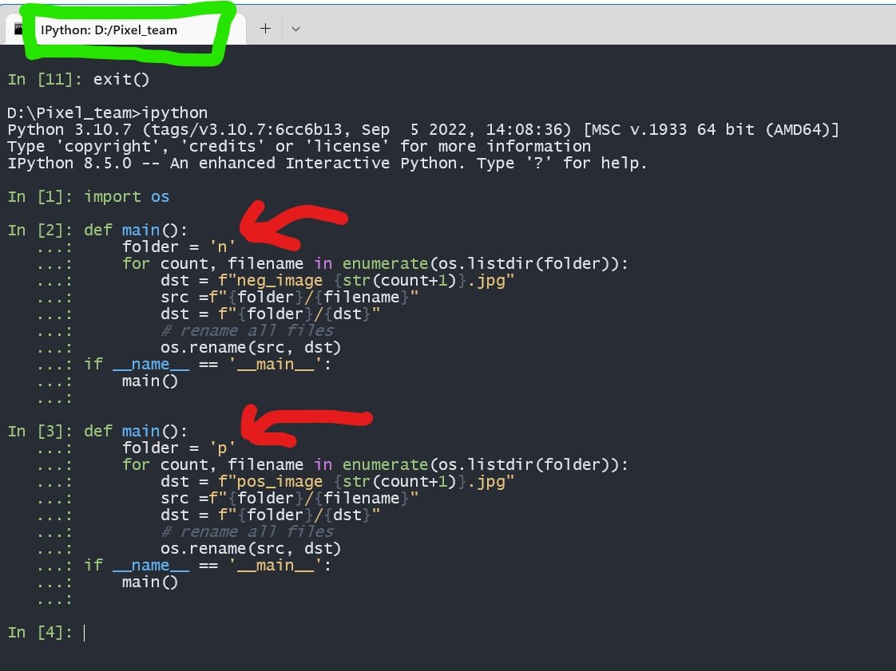

**Results:**

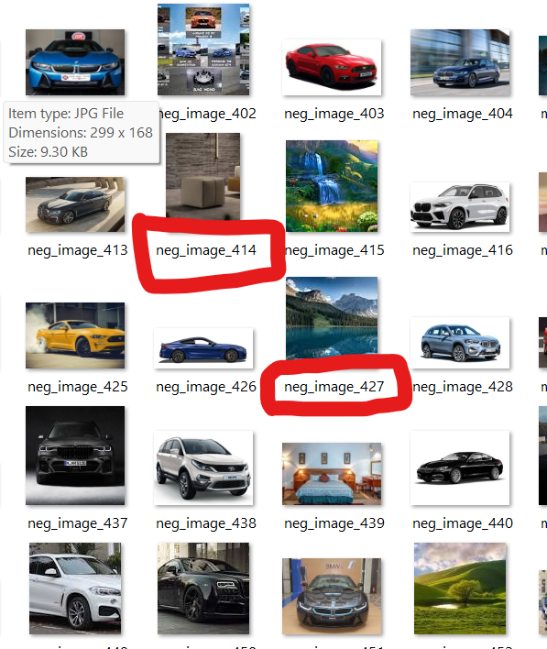

**Training:**

**

**Testing and Evaluation:**

**Average detection time:**

**: 0.022**

**Deploying the Project to GitHub:**

**As the size of negative and positive images are big, all files are uploaded excluding the image folders.**

**GitHub repository Link:** [**https://github.com/Jamshid-Ganiev/Viola-Jones-Algorithm-Face-Detection-Pixel-Team.git**](https://github.com/Jamshid-Ganiev/Viola-Jones-Algorithm-Face-Detection-Pixel-Team.git)

**Video: Included in GitHub repository.**